Name: ______________________________________ Date: ________________________

Student Exploration: Triple Beam Balance

Vocabulary: fulcrum, lever, mass, rider, triple beam balance

Prior Knowledge Questions (Do these BEFORE using the Gizmo.)

- A lever is a long beam that is set on a pointed fulcrum. A heavy rock is placed on a lever, as shown. Draw an arrow where you should push down to lift the rock most easily.

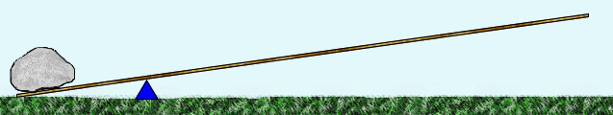

- Suppose you wanted to balance the rock with a smaller rock. Where would you put the smaller rock? Draw a smaller rock on the diagram above so that it balances the big rock.

Gizmo Warm-up
A triple beam balance is a type of lever that is used to measure mass, or the amount of matter in an object. An object with an unknown mass is placed on the measurement tray. On the other side of a fulcrum, a set of sliding weights, called riders, slide on beams to balance the object.

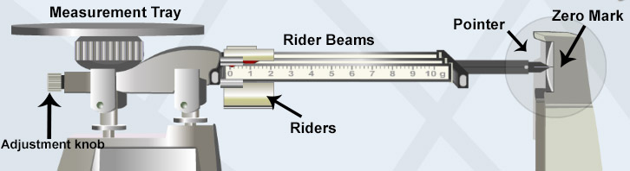

Practice using the balance in the Triple Beam Balance Gizmo.

- Where is the fulcrum of this lever? Circle and label its location on the diagram above.

- How do you balance the object on the measurement tray? __________________________

_________________________________________________________________________

Activity:  Measuring mass | Get the Gizmo ready:  - Set all the Riders to 0. | 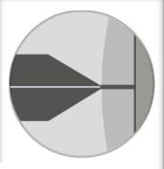

Question: How is a triple beam balance used to find mass?

- Observe: The riders have masses of 10 grams (top), 100 grams (middle), and 1 gram (bottom). Drag the 100-gram rider to 300. At this position it balances a 300-gram mass.

What happens to the pointer? ________________________________________________

- Compare: Place each object on the measurement tray, one at a time. Which objects have a mass greater than 300 grams? ________________________________________________
How do you know? _________________________________________________________

- Measure: Move the 100-gram rider back to 0. Place the light bulb on the tray.

- Move the 100-gram rider to the right, one notch at a time, until the pointer sinks. Now move the 100 gram rider back to the left one notch. (The pointer should lift up.)
- Move the 10-gram rider to the right, one notch at a time, until the pointer sinks below the zero mark. Now move the rider back to the left one notch.
- Slowly move the 1-gram rider until the pointer lines up with the zero mark.

- Calculate: The mass of the light bulb is the sum of the values on each rider. To get a magnified view of the 1-gram rider, place the cursor over that rider. (Each tick mark represents 0.1 g.)

100-g rider: ______________ 10-g rider: ______________ 1-g rider: ______________

Mass of the light bulb: ______________

Note: Because the position of the 1-g slider can be estimated to the nearest 0.01 g, the mass measurement is typically recorded to the nearest hundredth. For example, we would write 201.32 g or 146.70 g if the slider is exactly on a 0.1-g tick mark.

- Practice: Use the Gizmo to find the mass of the other objects. Write their masses below.

Paper clips: ______________ Cone: ______________ Cube: ______________

