Name: ______________________________________ Date: ________________________

Student Exploration: Pulleys

Vocabulary: effort, load, mechanical advantage, pulley, pulley system

Prior Knowledge Questions (Do these BEFORE using the Gizmo.)

- Suppose you had to haul a heavy bucket of water from a deep well. Which way do you think would be easiest for lifting the bucket? (Circle your answer.)
  - One person lifting the bucket.
  - Two people lifting the bucket.
  - Four people lifting the bucket.
  - One person using a pulley system to lift the bucket.

- Why did you choose the answer you chose? _____________________________________

_________________________________________________________________________

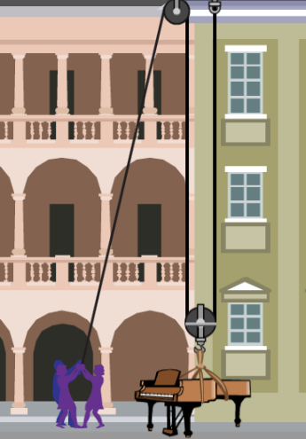
Gizmo Warm-up: Lifting a piano
A pulley is a simple machine that is used to lift heavy objects. A pulley is a wheel with a groove for a rope. Pulling down on one end of the rope causes the other end to pull up.

- In the Object to lift menu choose Piano. What is the weight of the piano? This is the load on the pulley.

Piano weight: _________ newtons (N).

- You can drag people over to the rope to try to lift the piano. Each person pulls with an effort of 200 newtons.

Are six people strong enough to lift the piano? ____________________________________

- You can change the number of pulleys using the Pulley type menu. Fixed pulleys are attached to the building and do not move. Moveable pulleys are attached to the object that is being lifted. Try different combinations until you lift the piano.

  - What type of pulley system did you use? _________________________________

  - How many people did it take to lift the piano using that system? ________________

Activity A:  Lifting with pulleys | Get the Gizmo ready:  - Click Reset.  - Under Pulley type, select 1 fixed.  - Under Object to lift, select Armchair.
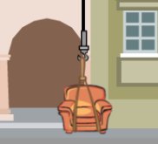
Question: How do pulleys help us to lift up objects?

- Hypothesis: Based on what you have seen, what is the relationship between the number of pulleys and the effort needed to lift a heavy object? (Fill in the sentence below.)

If more pulleys are used, then ______________________ effort is required.

- Collect data: Record how many people it takes to lift the armchair with each pulley type.

Pulley type | People needed to lift armchair
1 fixed
1 fixed, 1 moveable
2 fixed, 2 moveable
3 fixed, 3 moveable

- Analyze: What pattern do you see? _____________________________________________

_________________________________________________________________________

- Observe: Turn on Show information. The Rope on the ground shows how much rope has been pulled to lift the armchair. (The goal is to lift the armchair to the 3rd floor, 10 meters up.)

    - Lift the armchair 10 meters with 1 fixed pulley. How much rope was used? ________

    - How much rope is needed with the 1 fixed, 1 moveable pulley system? __________

    - How much rope is needed with the 2 fixed, 2 moveable pulley system? __________

    - How does the rope length relate to the number of pulleys in the system? _________

___________________________________________________________________

- Summarize: Explain what you have learned so far about pulleys. Why are pulleys useful?

_________________________________________________________________________

_________________________________________________________________________

_________________________________________________________________________

Activity B:  Mechanical advantage | Get the Gizmo ready:  - Under Pulley type, select 1 fixed.  - Under Object to lift, select Safe.  - Turn on Show the force of each rope. | 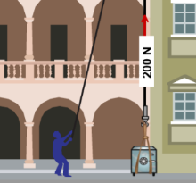

Question: How does a pulley system allow lifting with less effort?

- Observe: Drag one person to the rope. The number above the safe shows how much force is on the rope.

  - How much force is pulling the safe up? _________________________

  - Is there any advantage to using a single fixed pulley? Explain. _________________

___________________________________________________________________

___________________________________________________________________

- Observe: Change the Pulley type to 1 fixed, 1 moveable, and drag one person to the rope.

  - How many segments of rope are pulling up on the safe? ______________________

  - How much force is each segment pulling with? ______________________________

  - What is the total force pulling up on the safe? _______________________________

- Calculate: The mechanical advantage (MA) of a pulley system is the amount that the effort is multiplied. For example, if the effort is 100 N and the total force pulling up on the object is 400 N, the mechanical advantage is 4.

  - What is the mechanical advantage of a 1 fixed, 1 moveable system? ___________

  - How does the mechanical advantage compare to the number of rope segments pulling up on the safe? _________________________________________________

- Apply: Find the mechanical advantage of the other pulley systems. (Hint: Count the rope segments pulling up on the safe.)

2 fixed, 2 moveable: _________________ 3 fixed, 3 moveable: _________________

(Activity B continued on next page)
Activity B (continued from previous page)

- Extend your thinking: What would be the mechanical advantage of a pulley system with five fixed pulleys and five moving pulleys?

______________________________________

In the space at right, draw a picture of this system to support your answer.

- Compare: Think about lifting a heavy bucket of water from a deep well.

  - Which pulley system is equivalent to two people lifting the bucket? ______________

___________________________________________________________________

  - Which system is the same as four people lifting? ____________________________

  - Which system is the same as six people lifting? _____________________________

- Explain: How is a group of people pulling up on a bucket similar to the way a pulley system works? How is it different? If possible, discuss your answer with your classmates and teacher.

_________________________________________________________________________

_________________________________________________________________________

_________________________________________________________________________

_________________________________________________________________________

_________________________________________________________________________
Extension:  Pulley physics | Get the Gizmo ready:  - Select 1 fixed pulley and Armchair.  - Turn on Show the force on each rope and Show information. | 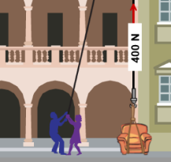

Question: Why is it easier to lift objects with pulleys?

- Predict: The armchair has a weight of 900 newtons. How much effort force do you think is needed to lift the armchair with one fixed pulley? Test your prediction using the Gizmo. (Effort is listed under Show information.)

Predicted effort: ________________________ Actual effort: ________________________

- Make a rule: If an object weighs x newtons, how much force is needed to lift it up? _________________________________________________________________________

- Calculate: Select the 2 fixed, 2 moveable pulley system. The mechanical advantage of this system is 4, so the total effort is multiplied by 4. Fill in the table to show how much force is produced as people are added. (Each person adds 200 newtons of effort.)

Number of people | Total effort | Mechanical advantage | Total lifting force
1 |  | 4
2 |  | 4
3 |  | 4
4 |  | 4
5 |  | 4
6 |  | 4

- Predict: The piano weighs 4,000 newtons. Based on the table and your rule, how many people will it take to lift the piano with this system? Use the Gizmo to test your answer.

Predicted number of people: ______________ Actual number of people: ______________

Were you correct? Explain. ___________________________________________________

- Challenge yourself: Use the same method to predict how many people it will take to lift the piano with a 3 fixed, 3 moveable pulley system. Write your calculations in your notebook or on a separate sheet of paper. Use the Gizmo to test your answer.

Predicted number of people: ______________ Actual number of people: ______________

