Name: ______________________________________ Date: ________________________

Student Exploration: Pollination: Flower to Fruit

Vocabulary: anther, cross pollination, filament, fruit, nectar, ovary, ovule, pedicel, petal, pistil, pollen, pollen tube, pollination, receptacle, self pollination, sepal, stamen, stigma, style

Prior Knowledge Question (Do this BEFORE using the Gizmo.)
Plants use sunlight to produce sugar. Flowering plants make some of this sugar available to animals in the form of nectar (a sweet liquid found in flowers) and fruit.

- Why do plants provide bees, butterflies, hummingbirds, and other animals with nectar?

_________________________________________________________________________

_________________________________________________________________________

- Why do plants provide animals with fruits such as strawberries, apples, and mangoes?

_________________________________________________________________________

_________________________________________________________________________

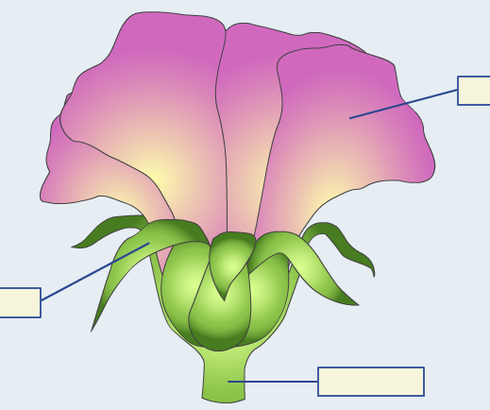
Gizmo Warm-up
Plants don’t produce nectar and delicious fruit just to be nice. As you will learn, bees and other pollinators play a critical role in helping plants to reproduce. Fruits play a role in allowing plants to spread to new locations.

The Pollination: Flower to Fruit Gizmo will take you through the reproductive cycle of flowering plants. To familiarize yourself with some of the parts of a flower, begin on the IDENTIFICATION tab.

- Look at the list of Flower Parts on the left. Which of these parts have you heard of before?

_________________________________________________________________________

- On the Closed view, drag the Petal, Pedicel, and Sepal terms into the correct spaces. (Use trial and error.) Turn on Show information about selected parts of the flower.

    - Which structure protects a maturing bud? _______________________

    - Which structure is a stalk that supports a single flower? _______________________

Activity A:  Flower anatomy | Get the Gizmo ready:  - On the IDENTIFICATION tab, select Opened view. | 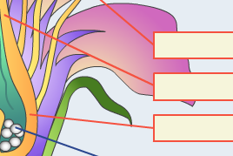

Goal: Identify the parts of the flower.

- Label: Drag the terms you have learned so far (Petal, Pedicel, and Sepal) into the diagram of the opened flower. The text at the top should say “Current status: 3 correct out of 14.” Add these terms to the diagram below.

Opened view

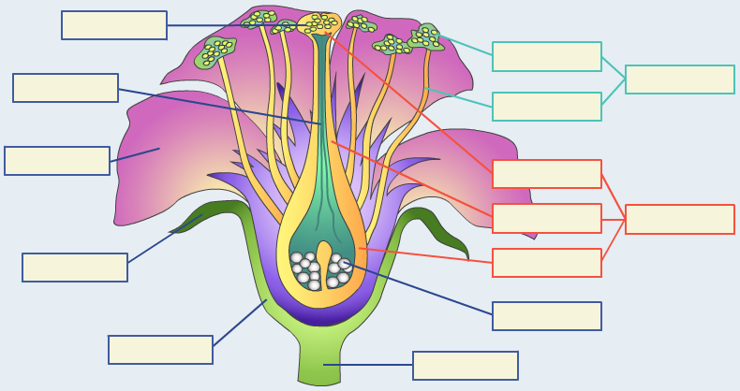

    - The receptacle is a cup-like structure that holds the flower. Label the receptacle on the Gizmo and then add this term to the diagram above.

    - The male part of the flower is called the stamen. It consists of two structures, a long, thin filament topped by an anther. Label these three structures in the Gizmo, and then add these terms to the diagram above.

    - The female part of the flower is called the pistil. It consists of a sticky top surface called the stigma, a shaft called the style, and an ovary that encloses small structures called ovules. Label all five parts in the Gizmo and in the diagram above.

    - Male sperm cells are contained within pollen grains. After a pollen grain moves from the anther to the stigma, a pollen tube grows through the style to an ovule. Label the last two structures in the Gizmo and in the diagram above.

If the current status now reads “14 correct out of 14,” then congratulations! You have identified all of the flower parts correctly. If not, revise your labels until they are correct.
(Activity A continued on next page)
Activity A (continued from previous page)

- Identify: If necessary, turn on Show information about selected parts of the flower, and read the information for each part. Identify the following parts from their descriptions.

    - These grains contain male gametes (sperm cells): __________________

    - This structure contains female gametes (egg cells): __________________

    - This colorful structure attracts pollinators to the flower: __________________

    - This structure has a sticky surface to trap pollen grains: __________________

    - This structure produces and stores pollen: __________________

    - These structures allow sperm cells to move through the style: __________________

    - This cup-like structure holds the flower: __________________

    - These structures protect the maturing flower bud: __________________

    - This structure contains the female organs of a flower: __________________

    - This structure contains the male organs of a flower: __________________

Activity B:  Pollination | Get the Gizmo ready:  - Select the POLLINATION/FERTILIZATION tab.  - Check that Self pollination is selected. | 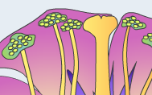

Question: How do flowering plants reproduce?

- Describe: Flowering plants reproduce by a process called pollination. Pollination is the transfer of pollen from the male to the female parts of the flower.

How do you think pollination takes place in flowering plants? _________________________

_________________________________________________________________________

_________________________________________________________________________

_________________________________________________________________________

- Summarize: Follow the directions in the Gizmo to observe the steps of self pollination. In your own words, describe what happens in each step.

1
2
3
4
5

(Activity B continued on next page)
Activity B (continued from previous page)

- Explain: What is the purpose of a fruit? __________________________________________

_________________________________________________________________________

_________________________________________________________________________

- Think and discuss: Think about what might happen to an apple when a deer finds it. How do you think this will help to spread the seeds in the apple? If possible, discuss your answer with your classmates and teacher.

_________________________________________________________________________

_________________________________________________________________________

_________________________________________________________________________

- Compare: Click Reset, and select Cross pollination. Go through the steps of cross pollination. How does cross pollination differ from self pollination?

_________________________________________________________________________

_________________________________________________________________________

- Think and discuss: Think about how pollen might travel from one flower to another.

    - What are some of the ways that pollen can travel from one flower to another?

___________________________________________________________________

___________________________________________________________________

    - Based on your answer to part A, why do you think many plants produce sweet nectar? _____________________________________________________________
___________________________________________________________________

- Infer: Some flowers are pollinated by wind or water. How do you think the petals of these flowers will be different from the petals on flowers pollinated by animals?

_________________________________________________________________________

_________________________________________________________________________

