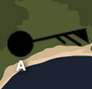
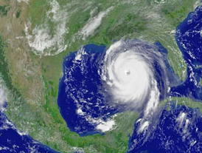
Name: ______________________________________ Date: ________________________

Student Exploration: Hurricane Motion

Vocabulary: air pressure, Coriolis effect, eye, hurricane, knot, meteorologist, precipitation

Prior Knowledge Questions (Do these BEFORE using the Gizmo.)
A hurricane is a large, rotating tropical storm with wind speeds of at least 119 kilometers per hour. Since 1990, meteorologists have regularly used satellite images to track hurricanes.

- The satellite image at right shows Hurricane Katrina just before it hit New Orleans in 2005. Label the hurricane on the image.

- How do you think meteorologists predicted the arrival of a hurricane before the 1990s?

_________________________________________

_________________________________________

Gizmo Warm-up
You can use data collected from weather stations to study the characteristics of hurricanes. The Hurricane Motion Gizmo has three simulated weather stations. Turn on Show weather station data. Make sure Wind, Cloud cover, and Pressure are all checked.

The tails on each station symbol point in the direction the wind is coming from. The flags on the tail indicate wind speed, measured in knots. (One knot is equal to 1.852 km/h.) A short line extending from the tail indicates 5 knots of wind. A longer line indicates 10 knots. A triangular flag indicates 50 knots. Add all the flags together to get the wind speed.

The number in the station’s upper right is the air pressure, measured in hectopascals (hPa).
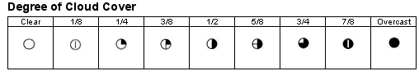
The circle symbol indicates the percentage of cloud cover, as shown in the table at right.

Use the information above to complete this table for station A on the Gizmo.

Wind speed (knots) | Wind from | Cloud cover | Pressure (hPa)

Activity A:  Hurricane characteristics | Get the Gizmo ready:  - Make sure Practice, Show hurricane, and Show weather station data are selected. | 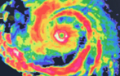

Introduction: Hurricanes form when an area of low pressure forms over warm water. Winds blow toward the low pressure, but are deflected by Earth’s rotation. The Coriolis effect causes winds to curve to the right in the Northern Hemisphere and to the left in the Southern Hemisphere. This results in a counterclockwise rotation for Northern Hemisphere hurricanes and a clockwise rotation for Southern Hemisphere hurricanes.

Question: What are some characteristics of hurricanes?

- Observe: In which hemisphere is the hurricane shown on the Gizmo? __________________

How do you know? _________________________________________________________

- Describe patterns: Under Show hurricane, make sure Radar is selected. Radar is used to determine where precipitation, such as rain, is falling. Blue indicates light rainfall. Heavier rain is shown with yellow and then orange. Red indicates the heaviest rainfall.
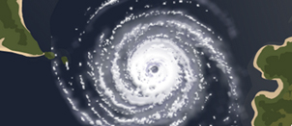
    - Where within the hurricane is the lightest rainfall? ___________________________

    - Where within the hurricane is the heaviest rainfall? __________________________

    - Describe any patterns you see in the distribution of a hurricane’s rain. ____________
___________________________________________________________________

- Observe: Under Show hurricane, select Satellite. Satellite images are taken from cameras built into satellites orbiting Earth. These images are used to study cloud coverage over large areas, including the clouds associated with a hurricane.

    - Which is larger, the area of rainfall or the area of cloud cover? __________________

    - Where is the cloud cover most dense? ____________________________________

    - Where is the cloud cover least dense? ____________________________________

- Identify: The center of rotation of a hurricane is called the eye. The eye of a hurricane is a core of warm, relatively calm air with low pressure and light winds. Label the eye on the hurricane at right.

(Activity A continued on next page)
Activity A (continued from previous page)
Category | Wind speed (mph)
1 | 119-153 km/h
2 | 154-177 km/h
3 | 178-209 km/h
4 | 210-249 km/h
5 | greater than 249 km/h

- Classify: Hurricanes are categorized based on their wind speeds. The chart at right shows the five categories used to classify hurricanes.

Move the hurricane so that the center of the storm is directly over one of the weather stations.

    - Remember one knot is equal to 1.852 kilometers per hour. What is the hurricane’s highest wind speed in kilometers per hour? ________________________________
- What category is this hurricane? _________________________________________

- Observe: Move the hurricane towards another weather station. As you do this, observe the cloud cover, wind speed, and air pressure at the station.

    - How does the cloud cover change? _______________________________________

- How does the wind speed change? _______________________________________

- How does the air pressure change? ______________________________________

- Collect data: Move a hurricane north, east, south, and west of a weather station. In the table below, record the wind direction in each case.

Hurricane position in relation to weather station | Wind direction at weather station
North
East
South
West

- Analyze: How can you tell the location of the hurricane relative to a weather station based on this information? _________________________________________________________
_________________________________________________________________________

_________________________________________________________________________

_________________________________________________________________________

Activity B:  Predict hurricanes | Get the Gizmo ready:  - Select Experiment and click Pause (). | 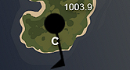

Question: How can you predict the location and path of a hurricane?

- Observe: Click Play (), and wait until you see a hurricane approaching one of the weather stations. Click Pause. What changes indicate a hurricane is approaching?

Cloud cover: _________________________ Air pressure: _________________________

Wind speed: _________________________

- Observe: Click Play, and wait for the hurricane to go over the land. What happens in the hours after landfall? _________________________________________________________

- Collect data: Click Reset (). Turn off Show hurricane. Click Play. When the simulation reads Day 1, 3:00 PM, click Pause and record the data from each weather station.

Station | Wind speed (knots) | Wind from | Cloud cover | Pressure (hPa)
A
B
C

- Interpret: Using the readings above, do you think a hurricane is nearby? Explain.

_________________________________________________________________________

_________________________________________________________________________

- Run Gizmo: Allow the Gizmo to run until the weather station data indicates a hurricane is nearby and will soon make landfall. Click Pause.

- What weather station data indicated a hurricane would soon make landfall?

___________________________________________________________________

___________________________________________________________________

- Turn on Show hurricane. Was your prediction correct? Explain. _______________

___________________________________________________________________

(Activity B continued on next page)
Activity B (continued from previous page)

- Gather data: Turn off Show hurricane, and click Reset. Click Play. At 12:00 p.m. of day 1, click Pause. Drag a pointer to the predicted position of the eye of the hurricane, and draw an arrow in the diagram below. Label this arrow “1.”

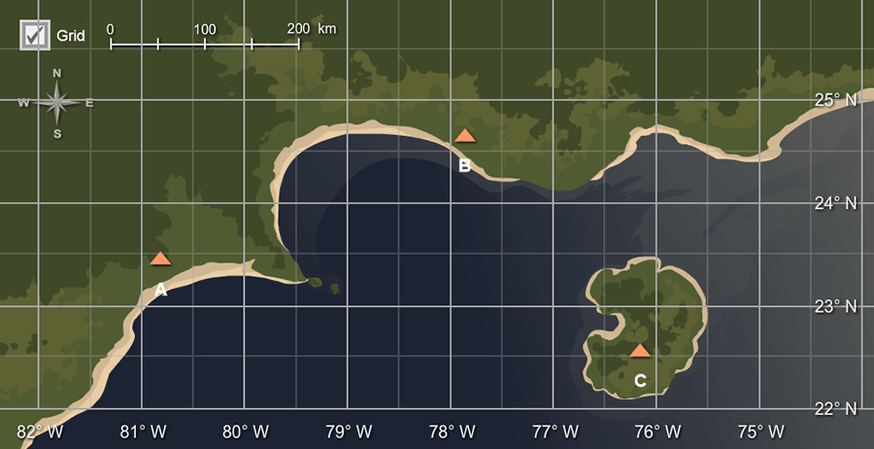

Turn on Show hurricane, and mark a circle where the actual eye is located. Label this circle “1.” Turn off Show hurricane, and then repeat this procedure every 12 hours to mark the predicted and actual path of the hurricane.

- On your own: Practice predicting the current and future positions of hurricanes. From the Tools tray, drag an arrow to where you think the eye of the hurricane is located. Turn on Show hurricane to check your prediction. Click on Tools and select screenshot (). Right-click the image, and click “Copy Image.” Take snapshots of the predicted and actual positions of the hurricane.

Paste your snapshots into a black document. Label each snapshot. Turn in your hurricane tracking document with this worksheet.

- Make connections: As warm, moist air rises, water vapor in the air condenses and releases a great deal of heat energy. This energy powers a hurricane. How does this information explain what happens to hurricanes after they make landfall?

_________________________________________________________________________

_________________________________________________________________________

_________________________________________________________________________

